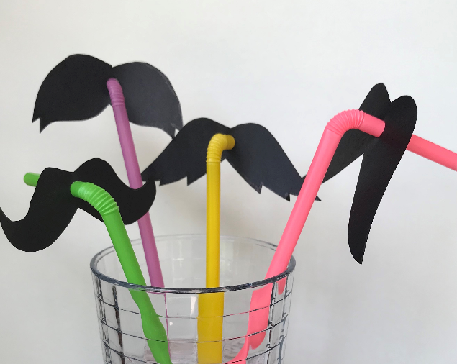
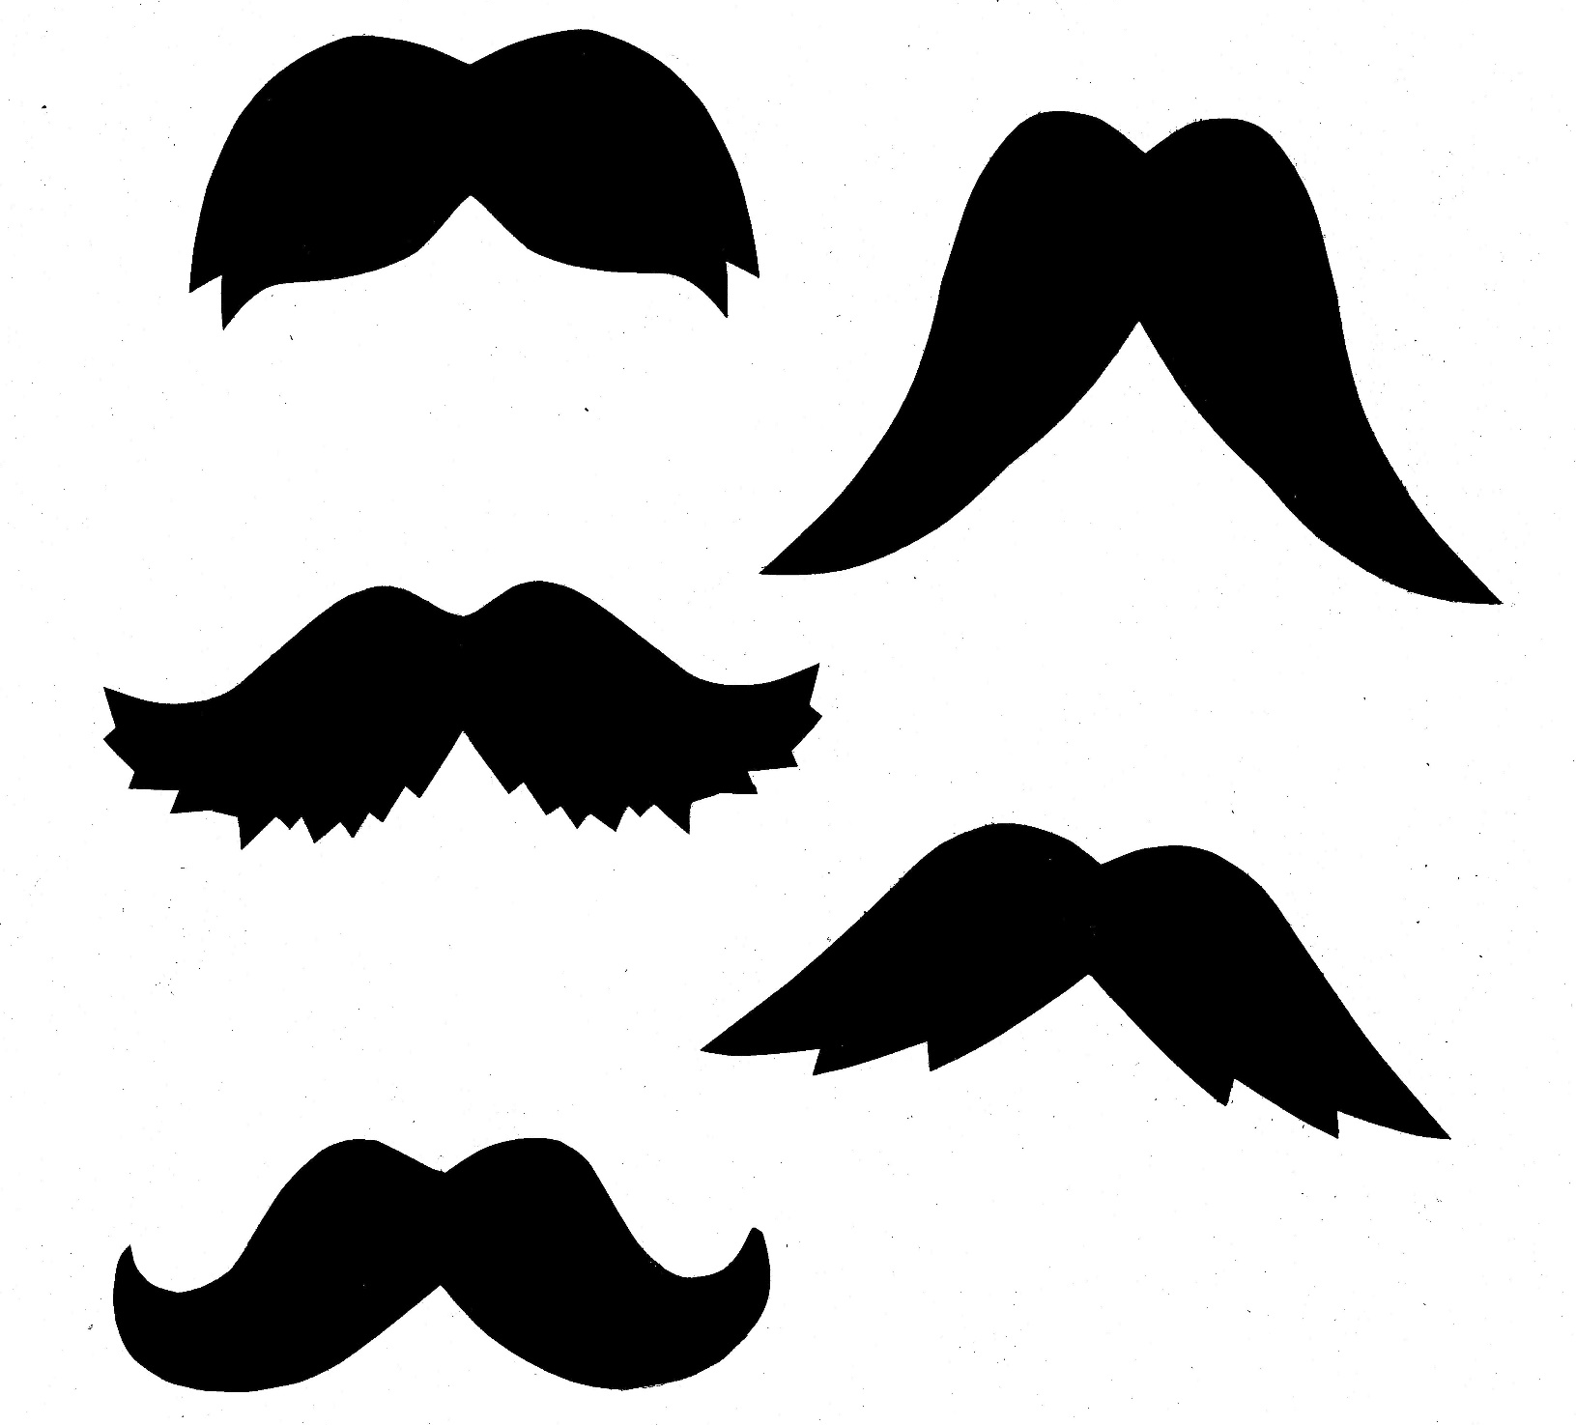
The Hero Dad
The Classic Dad
The Rock-N-Roll Dad
The Shaggy Dad
The He-Man Dad
- Cut out a moustache for your Dad.
- Punch a hole in the middle and insert a bendy straw.
Happy Father’s Day Moustaches
What kind of Dad do you have?

