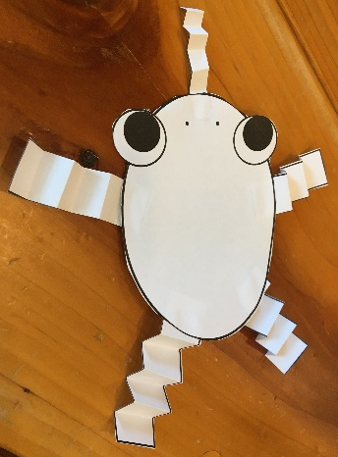
Wigglin’ Legs Frog
1. Color and cut out the frog’s body, legs, and tongue.
2. Fold the legs and tongue back and forth like an accordion.
3. Glue the legs and tongue to the frog’s body.

