MATERIALS LIST TO FOLLOW ALONG WITH MISS ARIEL DURING…
SILLY SCIENCE
THURSDAY JULY 30th @ 10:30
ON FACEBOOK LIVE

For experiment #1 you will need:
- 4 tablespoons of lemon juice OR the juice of 1 lemon
- 1 cup of water
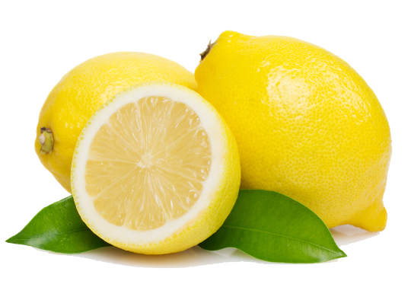
- 1 drinking cup (enough to hold lemon juice and water)
- ½ teaspoon baking soda
- 1 teaspoon sugar
For experiment #2 you will need:
- ½ cup of your favorite juice
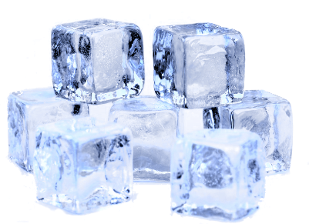
- 10 large ice cubes
- 1 cup salt
- 1 cup water
- 1 small plastic re-sealable bag
- 1 large plastic re-sealable bag

Can you guess what we are making? Tune in to find out!

